**Tabular Playground Series - Jan 2022**

(Kaggle link: <https://www.kaggle.com/c/tabular-playground-series-jan-2022/overview/description> )

**Description**:🡪

We've heard your feedback from the 2021 Tabular Playground Series, and now Kaggle needs your help going forward in 2022!

There are two (fictitious) independent store chains selling Kaggle merchandise that want to become **the** official outlet for all things Kaggle. We've decided to see if the Kaggle community could help us figure out which of the store chains would have the best sales going forward. So, we've collected some data and are asking you to build forecasting models to help us decide.

Help us figure out whether KaggleMart or KaggleRama should become the official Kaggle outlet!

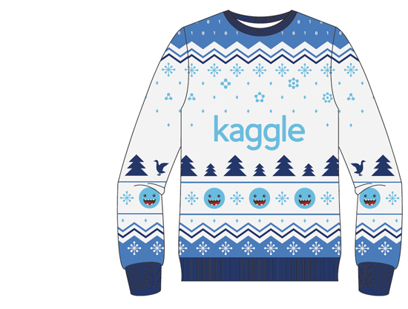

## About the Tabular Playground Series

Kaggle competitions are incredibly fun and rewarding, but they can also be intimidating for people who are relatively new in their data science journey. In the past, we've launched many Playground competitions that are more approachable than our Featured competitions and thus, more beginner-friendly.

The goal of these competitions is to provide a fun and approachable-for-anyone tabular dataset to model. These competitions are a great choice for people looking for something in between the Titanic Getting Started competition and the Featured competitions. If you're an established competitions master or grandmaster, these probably won't be much of a challenge for you; thus, we encourage you to avoid saturating the leaderboard.

For each monthly competition, we'll be offering Kaggle Merchandise for the top three teams. And finally, because we want these competitions to be more about learning, we're limiting team sizes to 3 individuals.

**Evaluation**:🡪

Submissions are evaluated on [SMAPE](https://en.wikipedia.org/wiki/Symmetric_mean_absolute_percentage_error) between forecasts and actual values. We define SMAPE = 0 when the actual and predicted values are both 0.

## Submission File

For each row_id in the test set, you must predict the corresponding num_sold. The file should contain a header and have the following format:

row_id,num_sold

26298,100

26299,100

26300,100

etc.